Polyglotica.AI Business Summary

Company Overview
Polyglotica.AI is an innovative AI-based language-learning company offering digital-only learning solutions through a mobile app and web platform. Our goal is to build a strong long-term customer base by providing high-quality learning modules with lifetime access. All operations are online, and English is used as the teaching language to learn Portuguese, Spanish, or French.
Product Offering
We offer seven structured learning modules supported by AI:
- Core proficiency modules: Beginner, Intermediate, Upper Intermediate, Advanced, Professional
- Supplement modules: Word Cards, Crosswords

Discount model
Our promotional model allows products to participate in multiple promotions over time through a many-to-many relationship. Each promotion has a defined start and end date and, when active, applies a fixed percentage discount to eligible products. Whether a promotion is applied to a specific purchase is determined by an external application, which considers factors such as customer age, gender, and the time elapsed since the last promotion. Consequently, promotion decisions cannot be fully automated within the database; the database stores only promotion definitions and product eligibility, while the application layer evaluates and applies them.
Rating system
Customers are encouraged to rate purchased modules in exchange for bonus materials such as additional vocabulary packs or crossword sets. Ratings help the company understand satisfaction across products and customer demographics.
Operational Model
A customer registers in the app, browses modules, and completes a purchase. Once payment is processed, the module is instantly unlocked. All learning, feedback delivery, billing, and communication occur digitally, with no physical materials involved. Upon each purchase, stock levels are updated and log entries are inserted through database triggers, ensuring consistent and real-time operational data.
Reports for marketing and planning
To support marketing strategy and product optimization, Polyglotica.AI prepares the following analytical reports:
- Top 5 customers by historical purchases — identifies high-value learners.
- Annual Sales by Year and City — evaluates geographic performance over time.
- Annual Sales Pivot by City (2023–2025) – provides a clearer view of how each city's performance evolves over time.
- Year-over-Year Sales Δ by City — highlights performance changes and allows identification of growth or decline.
- Customer Product-Group Sales Summary (with Totals) – provides alternative slicing of data with the same totals.
- Top-rated products by Gender and Age — Highlights modules preferred by specific demographic groups.

Enhanced Entity–Relationship Diagram (EERD)
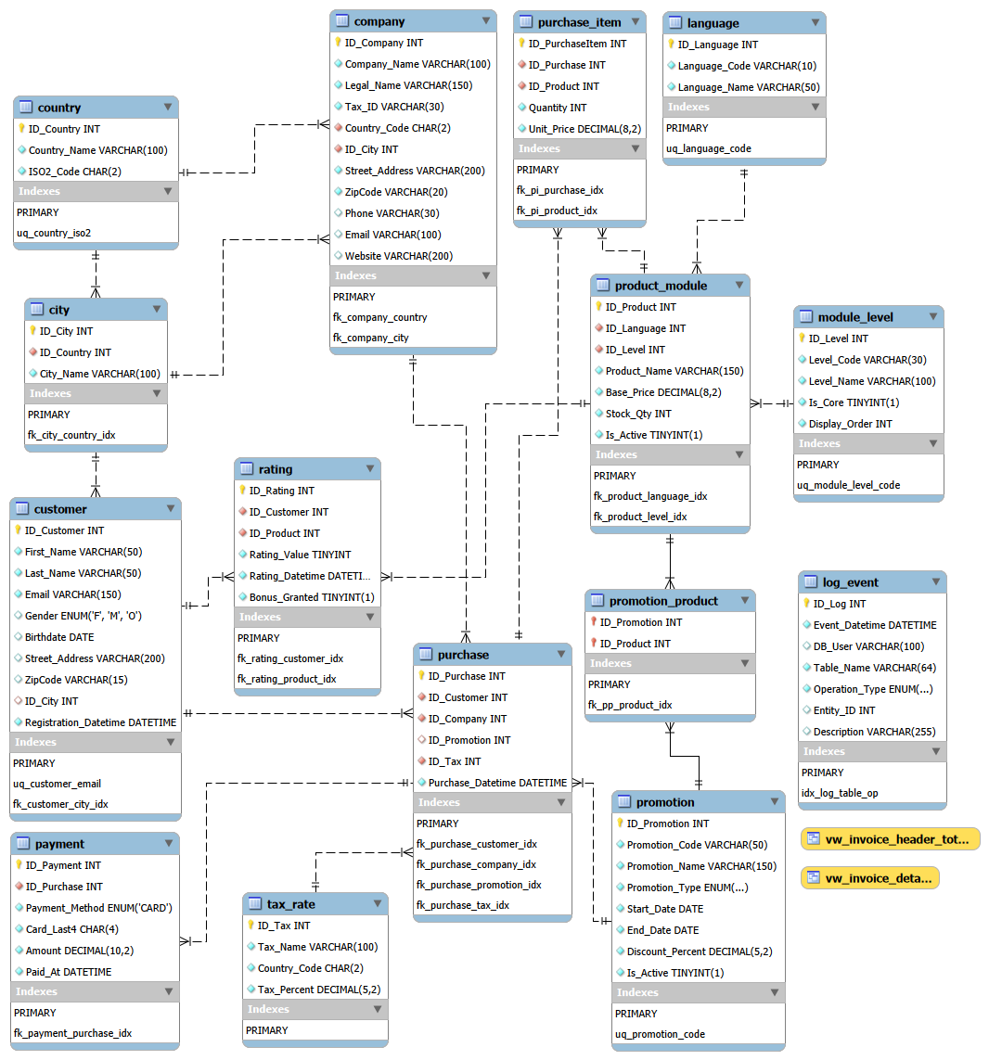
1. Geography & Parties
Tables: country – city – company – customer
Relationships
1→many links
- One country → many cities, many companies, many customers (via city).
- One city → many companies and many customers.
Insert / duplicate rules
- You cannot insert a city with ID_Country that doesn’t exist in country → FK error.
- You cannot insert a company or customer with ID_City that doesn’t exist → FK error.
- You cannot insert a second country with the same ISO2_Code, or customer with same Email → unique-key error.
Delete / update rules
- country / city deletions are restricted if used by companies (business rule: a company must always have a valid country and city).
- customer.ID_City is set to NULL when city is deleted (business rule: a customer may exist without a stored city).
- PK/Code changes on parent are propagated by ON UPDATE CASCADE to children (business rule: child records must always reference the current, valid parent key).

2. Product Catalog
Tables: language – module_level – product_module
Core design:
product_module is an associative table linking one language and one module level to define a concrete product (with name, price, stock, etc.).
Relationships
- One language → many product_module
(business rule: many products can belong to the same language—e.g., all Portuguese products across different levels)
- One module_level → many product_module
(business rule: the same level (e.g., Beginner) is reused across different languages)
Insert / duplicate rules
- You cannot insert a product_module with an ID_Language or ID_Level that doesn’t exist → FK error
(business rule: a product must reference valid language and level master data)
- You cannot insert another language with the same Language_Code or another module_level with the same Level_Code → unique-key error
(business rule: languages and levels are defined uniquely)
- You cannot delete a language or module_level if any product_module references them → delete blocked (RESTRICT)
(business rule: you cannot remove a language or level that is still used by existing products)

3. Marketing
Tables: promotion – promotion_product – product_module
Core design:
Promotions apply to selected products.
promotion_product is the only true junction table in the EERD because it uses a composite primary key made of two foreign keys (ID_Promotion, ID_Product), implementing a many-to-many relationship.
Relationships
- One promotion → many promotion_product
(business rule: a single promotion can be applied to multiple products)
- One product_module → many promotion_product
(business rule: a product can appear in multiple different promotions)
- Therefore:
promotion ↔ product_module is a many-to-many relationship
implemented exclusively through promotion_product (the junction table).
Insert / duplicate rules
- PK = (ID_Promotion, ID_Product) prevents inserting the same pair twice → PK error
(business rule: a product cannot be added twice to the same promotion)
- You cannot insert a row with non-existing ID_Promotion or ID_Product → FK error
(business rule: only valid promotions and products can be linked)
Delete rules
- You cannot delete a product if it is referenced in promotion_product (ON DELETE RESTRICT)
(business rule: products involved in promotions cannot be removed without first removing links)
- Deleting a promotion automatically deletes its entries in promotion_product (ON DELETE CASCADE)
(business rule: when a promotion is deleted, all product associations must also be removed)
4. Ratings
Tables: customer – rating – product_module
Core design:
rating is an associative (‘junction’) table between customer and product_module.
Each rating links one customer and one product, with additional attributes such as Rating_Value, timestamp, and Bonus_Granted.
Relationships
- One customer → many rating
(business rule: a customer can rate multiple products over time)
- One product_module → many rating
(business rule: the same product can receive ratings from many customers)
- Because rating contains ID_Customer and ID_Product, it implements a many-to-many relationship between:
customer ↔ product_module via rating
(business rule: any customer can rate any product they used)
Insert / duplicate rules
- You cannot insert a rating with a non-existing ID_Customer or ID_Product → FK error
(business rule: ratings must refer to valid customers and valid products)
- The primary key ID_Rating ensures each rating is uniquely identifiable
(business rule: each rating event is stored as a distinct record)
(Note: the schema does not prohibit multiple ratings per customer per product—the model allows repeated ratings.)
Delete rules
- Deleting a customer deletes all their rating rows (ON DELETE CASCADE)
(business rule: if a customer is fully removed from the operational system (e.g., account deletion / privacy request), their ratings must also be removed so that no rating points to a non-existing customer.)
- Deleting a product_module deletes all its rating rows (ON DELETE CASCADE)
(business rule: rating loses meaning once a product is removed)
- rating does not affect other tables; it is dependent on both parents and has no children.

4. Purchases & Invoicing
Tables: purchase – purchase_item – payment – tax_rate – promotion – customer – company
Core design
- purchase = order / invoice header (who bought, from which company, when, which tax, which promotion).
- purchase_item = order lines (which products, quantities, line prices).
- payment = card payment for a purchase.
- tax_rate = VAT definition used by purchases.
- promotion = optional discount attached to some purchases.
- customer and company = parties in the transaction (buyer and seller).
Relationships
- One customer → many purchase
(business rule: a customer can place multiple orders over time)
- One company → many purchase
(business rule: each office issues many invoices)
- One tax_rate → many purchase
(business rule: the same VAT definition is reused by many invoices)
- One promotion → many purchase (optional)
(business rule: the same promotion can be applied to many orders)
- One purchase → many purchase_item
(business rule: one order can contain several products/lines)
- One product_module → many purchase_item
(business rule: the same product can appear in many different purchase items belonging to different orders)
- One purchase → many payment
(business rule: an order can be paid with one or more card payments (e.g., installments); in the sample dataset each purchase has a single payment, but the schema intentionally allows multiple payments per order to support future scenarios such as installment plans.)
Insert / duplicate rules
- You cannot insert a purchase with non-existing ID_Customer, ID_Company, ID_Tax or ID_Promotion → FK error
(business rule: every order must reference valid buyer, seller, tax, and (if used) promotion)
- You cannot insert a purchase_item with non-existing ID_Purchase or ID_Product → FK error
(business rule: each line must belong to an existing order and product)
- You cannot insert a payment with non-existing ID_Purchase → FK error
(business rule: payments must always be tied to real orders)
- Primary keys in all purchase-related tables (customer, company, tax_rate, promotion, purchase, purchase_item, payment) must be unique
(business rule: every party, tax, promotion, order, line, and payment has its own identifier).
Delete / update rules
- Deleting a purchase deletes its purchase_item and payment rows (ON DELETE CASCADE)
(business rule: when an order is removed, its lines and payment must not remain orphaned)
- Deleting a product_module is blocked if it is used in purchase_item (RESTRICT)
(business rule: products already sold in orders cannot be removed from the catalog)
- Deleting a promotion sets purchase.ID_Promotion to NULL (ON DELETE SET NULL)
(business rule: if a promotion is deleted, existing orders are kept, and only the promotion reference is cleared (set to NULL); orders themselves can also be deleted independently when needed.)
- Deleting a customer, company, or tax_rate is restricted when purchases reference them (RESTRICT)
(business rule: you cannot remove key business parties or tax definitions that are still used in invoices)
- ON UPDATE CASCADE on purchase FKs ensures that if IDs in parent tables change, all related purchase, purchase_item, and payment rows stay consistent
(business rule: child records must always follow the current keys of their parent entities)

